AID - CXR

AID - CXR: Assessing artificial Intelligence for the Diagnosis of Cancer on chest-XRays

V2.1 30/01/2026

MAIN SPONSOR: Imperial College Healthcare NHS Trust
FUNDERS: The AI Diagnostic Fund
STUDY COORDINATION CENTRE: Imperial College Healthcare NHS Trust

IRAS Project ID: 348965
REC reference: N/A

Protocol authorised by:

Name & Role | Date | Signature
Prof Sue Copley

Study Management Group

Chief Investigator: Prof Sue Copley

Co-investigators: Prof Andrea Rockall, Dr Monica Whittle, Dr Mitchell Chen, Dr Girija Agarwal, Lesley Honeyfield

Statistician: N/A

Study Management: Tina Stoycheva

Study Coordination Centre (may not be applicable)

For general queries, supply of study documentation, and collection of data, please contact:

Study Coordinator: Tina Stoycheva
Address: Charing Cross Hospital, Fulham Palace Road, W68RF
Tel: 020331 10327 E-mail: tina.stoycheva@nhs.net

Clinical Queries

Clinical queries should be directed to Tina Stoycheva who will direct the query to the appropriate person.

Sponsor

Imperial College Healthcare NHS Trust is the main research Sponsor for this study. For further information regarding the sponsorship conditions, please contact the Head of Regulatory Compliance at:

Research Governance and Integrity Team
Imperial College London and Imperial College Healthcare NHS Trust
Room 215, Level 2, Medical School Building
Norfolk Place
London, W2 1PG
Tel: 0207 594 9480
Imperial College - Research Governance and Integrity Team (RGIT) Website

Funder

The AI Diagnostic Fund

This protocol describes the AID - CXR study and provides information about procedures for entering participants. Every care was taken in its drafting, but corrections or amendments may be necessary. These will be circulated to investigators in the study. Problems relating to this study should be referred, in the first instance, to the Chief Investigator.

This study will adhere to the principles outlined in the UK Policy Frame Work for Health and Social Care Research. It will be conducted in compliance with the protocol, the Data Protection Act and other regulatory requirements as appropriate.

Table of Contents Page No
1. INTRODUCTION 5
1.1. BACKGROUND 5
1.2. RATIONALE FOR CURRENT STUDY 7
2. STUDY OBJECTIVES 9
3. STUDY DESIGN 9
3.1. STUDY OUTCOME MEASURES 10
4. PARTICIPANT ENTRY 10
4.1. INCLUSION CRITERIA 10
4.2. EXCLUSION CRITERIA 10
5. ADVERSE EVENTS 11
6. ASSESSMENT AND FOLLOW-UP 11
7. STATISTICS AND DATA ANALYSIS 11
8. REGULATORY ISSUES 11
8.1. ETHICS APPROVAL 11
8.2. CONSENT 11
8.3. CONFIDENTIALITY 11
8.4. INDEMNITY 12
8.5. SPONSOR 12
8.6. FUNDING 12
8.7. AUDITS 12
9. STUDY MANAGEMENT 12
10. PUBLICATION POLICY 12
11. REFERENCES 12

Glossary of Abbreviations
NHS | National Health Service
NIHR | National Institute of Health Research
HRA | Health Research Authority
ICHT | Imperial College Healthcare NHS Trust
PACS | Picture Archiving and Communication System
Research PACS | Research Picture Archiving and Communication System
ICHT | Imperial College Healthcare NHS Trust
RE | Radiomics Enabler
CTP | Clinical Trials Processor
AI | Artificial Intelligence
CXR | Chest radiography
CT | Computed tomography
FDS | Faster Diagnostic Standard

Keywords
Artificial Intelligence, NHS, Radiology, Lung cancer detection, AI

Study Summary

TITLE | AID - CXR: Assessing artificial Intelligence for the Diagnosis of Cancer on chest-XRays
DESIGN | Retrospective data collection study
AIMS | 1. To assess the detection rate of the AI software for lung cancer on CX  2. To evaluate the full diagnostic performance of the AI software for lung cancer detection on CXR.  3. To investigate the impact on time to diagnosis by the AI software for lung cancer on CXR.  4. To compare the actual chest CT referral numbers with referral numbers when aided by AI.  5. To identify patient groups and technical factors that would limit the efficacy of the AI software for an accurate diagnosis.
OUTCOME MEASURES | The primary outcome measure is the sensitivity of the AI software for lung cancer detection on CXR.  Secondary outcomes include other diagnostic performance measures including specificity, positive and negative predictive values, and area under the ROC curve.
POPULATION | Adult patient population with outpatient chest X-ray exams.
ELIGIBILITY | INCLUSION CRITERIA  • Patients aged 18 and over.  • Patients who had an Outpatient, Emergency Department or a General Practitioner referral for a chest X-ray.  • Patients with a CXR available on ICHT PACS who have undergone CXR examination between January 2018 and December 2018.  • Patient diagnosed with lung cancer at ICHT between January 2016 and August 2018 who have had CXR in the 12 months preceding their diagnostic CT scan.  EXCLUSION CRITERIA  • Corrupted DICOM files.  • No known outcome to the cancer question  • CXR not suitable for AI software analysis
duration | 24 months

INTRODUCTION

  - BACKGROUND

Worldwide, lung cancer is the leading cause of cancer death and has a poor prognosis ^{1,2}. Approximately 46,700 new patients are diagnosed with lung cancer annually in the UK.¹ Patients often present late (Stage 3 and 4) as they are often asymptomatic in the early stages, with persisting cough, shortness of breath and coughing up blood symptoms of advanced disease¹.

In the UK patients in deprived areas are more likely to die of cancer, mostly due to lung cancer, the UK’s most common cause of death from cancer. Lung cancer has by far the highest excess cases attributable to deprivation of any cancer type, with 14,000 excess cases in England alone each year. It also represents more than half of all excess cancer deaths related to deprivation, with the 5-year survival rate falling from 19% to 12% for the least to most deprived groups. However, the NHS Plan aims to diagnose 75% of all cancers as stage 1 or 2 by 2028. Patients detected at a later stage have poorer outcomes³.
The National Optimal Lung Cancer Pathway was launched in 2017 to support improvement in lung cancer services.

The recently introduced Faster Diagnostic Standard (FDS) to have cancer ruled out or diagnosed within 28 days of referral, reducing patient stress and anxiety, is 75%. This provides the focal point for improvement to the clinical pathway. Latest performance reports for Northwest London show sub optimal cancer performance in the percentage of patients waiting 29+ and 63+ day pathways.

The reported position for lung cancer patients in May 2023 was 23% within 29+ days and 39% within 63+ days, demonstrating a clear impetus for improving the speed of local cancer pathways.

There are multiple sources of referral into the lung cancer pathway all of which currently include access to chest radiography (CXR). GP referrals on the current cancer pathway require a CXR to be requested at the point of referral. The CXR result is used to inform the triage of referrals and potential onward referral needs. GP referrals for CXR outside of the cancer pathway include patients where the clinical suspicion of cancer did not meet the NG12 threshold (NG12 recommendations for lung cancer:
https://www.nice.org.uk/guidance/ng12/chapter/Recommendations-organised-by-site-of-cancer#lung-and-pleural-cancers).
This cohort represents most consultant upgrades to the lung cancer pathway and typically have longer delays.

The national turnaround times for reporting were launched on 9th August 2023 and require all urgent GP requests to be reported within 7 days, routine request by 28 days with requests for patients on a cancer pathway to be reported within 3 days. Report turnaround time is a critical dependency within the lung cancer pathway, even minor delays therefore have a significant impact on this turnaround time. At present the referral status is visible within the reporting worklist showing 2WW, urgent and routine. Radiographers are asked to escalate abnormal findings suspicious of lung cancer for ‘hot reporting’.

Moreover, the diagnostic radiology workforce is not keeping pace with demand for services. In 2022, the clinical radiology workforce grew by just 3%. In comparison, demand for diagnostic activity is rising by over 5% annually. The UK now has a 29% shortfall of clinical radiologists, which is expected to rise to 40% in five years. Innovative technologies are sought to provide mitigation for the rising demand on the current workforce.

  - RATIONALE FOR CURRENT STUDY

The introduction of AI software can improve diagnostic accuracy, highlight abnormal cases for rapid reporting and reduce the overall reporting workload has potential to significantly impact the performance of the lung cancer pathway.

- Assist with early-stage diagnosis
Provides diagnostic assistance to expert radiologists, reducing missed lung cancers by up to 60%⁴ helping to identify early-stage, hard to spot cancers. AI-augmented reporting also standardises reporting performance
- Expedite the detection of lung cancer
AI CXR software can improve triage of cases suspicious of lung cancer (SLC) to be highlighted for immediate reporting and, if the reporter agrees with SLC flag, be scheduled for same-day CT, fast-tracking diagnosis

- Reduce pressures on radiology department (additional benefit)
Diagnose and report normal CXRs from radiologist workload (up to 30% of all CXRs) with a very low error rate. Removing normal auto-reported CXRs adds radiology capacity back into the system, allowing radiologists to better focus on more complex and urgent cases. Reduce the time to report an individual study by identifying abnormalities for inclusion in the report.

The above assertions are supported by published research and pilot projects⁵.

However, NICE recommends further research in artificial intelligence (AI)- derived software alongside clinician review to assess the risks and benefits in routine care⁷. NICE have identified the following evidence gaps which require further research evaluation:

- Referral to CT scan.

The review of CXRs determines whether people will proceed to have a chest CT scan. This may be influenced by the assessed AI technologies. To understand the impact on resource use, it is necessary to understand how AI software affects the proportion of people with CXRs who are referred on to chest CT and the overall number of referrals to CT.

- Time to CXR review, CT referral and diagnosis.

An advantage at the software may be in supporting quicker review and reporting of chest x-rays, leading to quicker referral to chest CT scan and diagnosis. An additional advantage of using AI derived software to interpret images is that the algorithm can prioritize the images for the review if abnormal findings are detected. This can be assessed by measuring:

- time from CXR to report
- average number of CXRs assessed per reviewer per day

For those who are referred on to CT scan, it is important to assess how the software affects the time from receipt of CXR to CT scan.
The benefits of the technology when used by less experienced reporters such as trainee radiologists, and reporting radiographers should also be considered when collecting data for this outcome.

- Diagnostic accuracy and technical failure rate.

AI derived software may improve a CXR reporter’s ability to identify images with features suggesting lung cancer. Improving sensitivity to abnormalities could result in earlier diagnosis, but unnecessary referrals to CT incur costs to the NHS and may cause patient anxiety.
Information on diagnostic accuracy (positive predictive value) could be assessed by measuring the proportion of abnormal chest x-rays that are confirmed as abnormal by the chest CT scan. Information on the number of cancers detected and missed, stage of cancer at diagnosis, is also important to inform the economic model.
Technical failure and rejection rates should also be collected.

Evidence that further supports committee decision-making:

- Software impact on health care costs and resource use.

Further information on resources needed to implement these technologies a clinical practice is important for use in the economic modelling to inform decision-making. For example, training and software implementation costs.

- Evidence and populations with underlying conditions that could yield images that are challenging to interpret.

There is currently a lack of evidence for these technologies in people with conditions that may result in images that are challenging to interpret. Lung nodules and other abnormalities may be difficult to recognise in people with conditions such as asthma, scoliosis, obesity or chronic obstructive pulmonary disease.

- Clinician experience of using AI derived software.

Information on ease of use and acceptability of the software by clinicians is needed. This may include experiences around implementing the technology and any improvement in the delivery of diagnostic services, particularly around accuracy of the technology in identifying abnormalities, appropriateness of image triage and the impact on speed of review and reporting.

STUDY OBJECTIVES

2.1 PRIMARY OBJECTIVE

To assess the detection rate of the AI software for lung cancer on CXR

2.2 SECONDARY OBJECTIVES

2.2.1 To evaluate the full diagnostic performance of the AI software for lung cancer detection on CXR.

2.2.2 To investigate the impact on time to diagnosis by the AI software for lung cancer on CXR.

2.2.3 To compare the actual chest CT referral numbers with referral numbers when aided by AI.

2.2.4 To identify patient groups and technical factors that would limit the efficacy of the AI software for an accurate diagnosis.

2.2.5 To establish technical failure and rejection rates of the AI software.

STUDY DESIGN

This is a retrospective data collection study which will use routinely acquired outpatient chest X-ray exams from the adult patient population. The CXRs are available on the Imperial College Healthcare NHS Trust PACS and have been performed as part of patients’ standard of care between January 2016 and December 2018.

Patients will be identified through electronic search of the radiology imaging system (Soliton) by members of the of the research team who are also part of direct clinical care. Relevant patients will be identified by searching for specific keywords (e.g. lung cancer) and by type of exam (e.g. X-ray).

The identified cases will be retrieved from ICHT PACS through the Radiomics Enabler and pseudonymised via the Clinical Trials Processor. This is part of an existing workflow for data anonymization, which has been approved by the Caldicott guardian at Imperial College Healthcare NHS Trust. The current output of the Clinical Trials Processor is a research PACS instance, which is a Trust system holding only pseudonymised or fully anonymised data.

Once the imaging data has been pseudonymised it will be sent to the Qure gateway (AWS cloud). The images will be analysed by the Quire.AI (Bengaluru, India) and the AI output will be sent back to research PACS in the Trust. (Figure 1)

Clinical information (including but not limited to age, gender, MDT diagnosis, cancer histology, stage, treatment, treatment outcome and prognosis) will also be collected from electronic medical records system (Cerner) which will also be pseudonymised. The pseudonymised clinical data will be entered onto an Imaging REDCap instance hosted within the Trust.

Access to the Trust’s research PACS is restricted to imaging staff with individual accounts provided by Imaging IT.

Access to the Trust’s anonymization software and the Trust REDCap instance is restricted to imaging staff with individual accounts provided by Imaging Research Team.

The sample size for this study is 53,000 patients who had a CXR from GP, outpatient (OP) and emergency department (ED) referrals in 2018. . A further subset of approximately 1,000 CXRs taken from patients diagnosed of lung cancer between January 2016 and August 2018 will also be included.

Reason of referral, whether it was for suspected cancer or other indications, will be documented to separate the CXR into ‘suspected cancer’ and ‘other’ groups.

The AI software, qXR (Qure.AI), is a CE Class IIb-marked medical device, which analyses CXRs that meets its inclusion criteria (Appendix 1). It detects suspicious abnormalities in the chest X-ray, including lung lesions, cavity, hilar enlargement, mediastinal masses and mediastinal widening. It can localise the abnormalities and provide clinically relevant tags, with results intended to be used to support radiologists or other licensed medical practitioner in clinical decision making.

For this study, we would consider lung nodule, mass or cavity, hilar enlargement, mediastinal masses and mediastinal widening as cancer suspecting abnormalities.

qXR uses thresholds for abnormality detection on CXR. Pre-determined thresholds from North West London will be used in this study, with the option to update the thresholds based on our findings and re-assess the tool performance as the Chief Investigator sees fit.

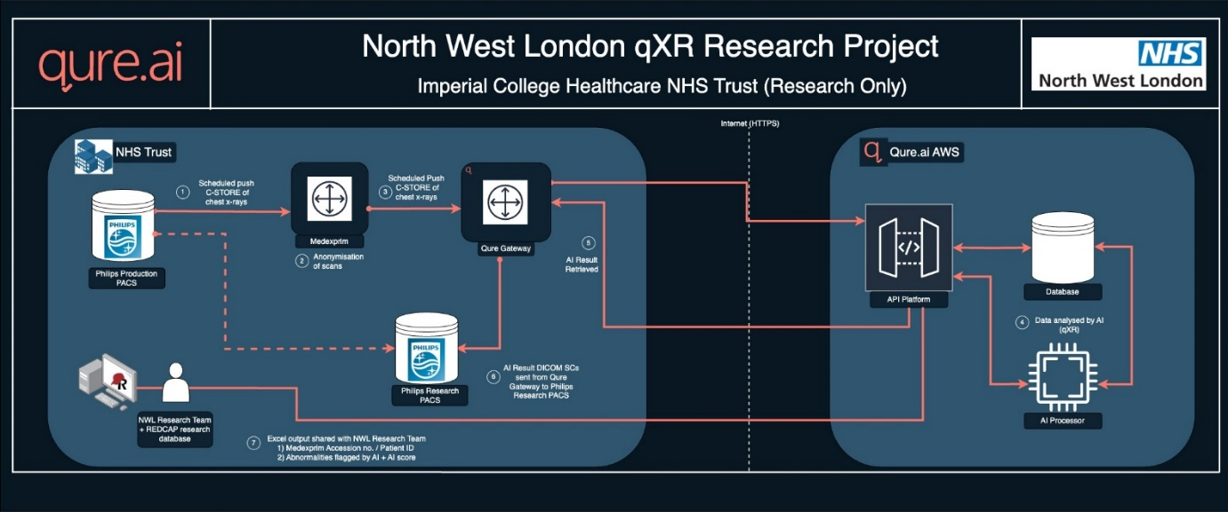
Suspected cancer patients (based on their CXR) would be retrospectively followed for 3 years from their time of diagnosis, with cancer diagnosis made either on histology or MDT diagnosis. Overall survival at 3 years will be used as the main prognostic measurement for lung cancer cases.

Fig.1: Data transfer pipeline between ICHT and Qure.AI

Personal data will be stored in electronic format within a secure password protected NHS network at Imperial College Healthcare NHS Trust.

The long term arrangements for storage of research data will be in electronic format on Trust computers and will follow Imperial College Healthcare NHS Trust policy.

No data will be retained or stored by Qure.AI.

  - STUDY OUTCOME MEASURES

Primary: The primary outcome measure is the sensitivity of the AI software for lung cancer detection on CXR. This will be assessed by comparing the accuracy of AI identification of lung cancer on CXR in 12 months of retrospective data from 2018 at ICHNT using qXR evaluation of false positives and false negatives as well as true positives and true negatives will be performed by comparison with CT findings and final histopathological diagnosis of lung cancer. The reference truth will be the MDT or histology diagnosis (Figure 2).
Patients with histologically confirmed lung cancer diagnosed between Jan 2016 and Aug 2018 at ICHT will be included in this study to increase the number of positive cases of lung cancer and evaluate the sensitivity for the AI tool to detect earlier lung cancer on the CXRs obtained up to 12 months prior to diagnosis. Up to 4 CXRs in the 12 months preceding their diagnostic CT will be included. (Figure 3)

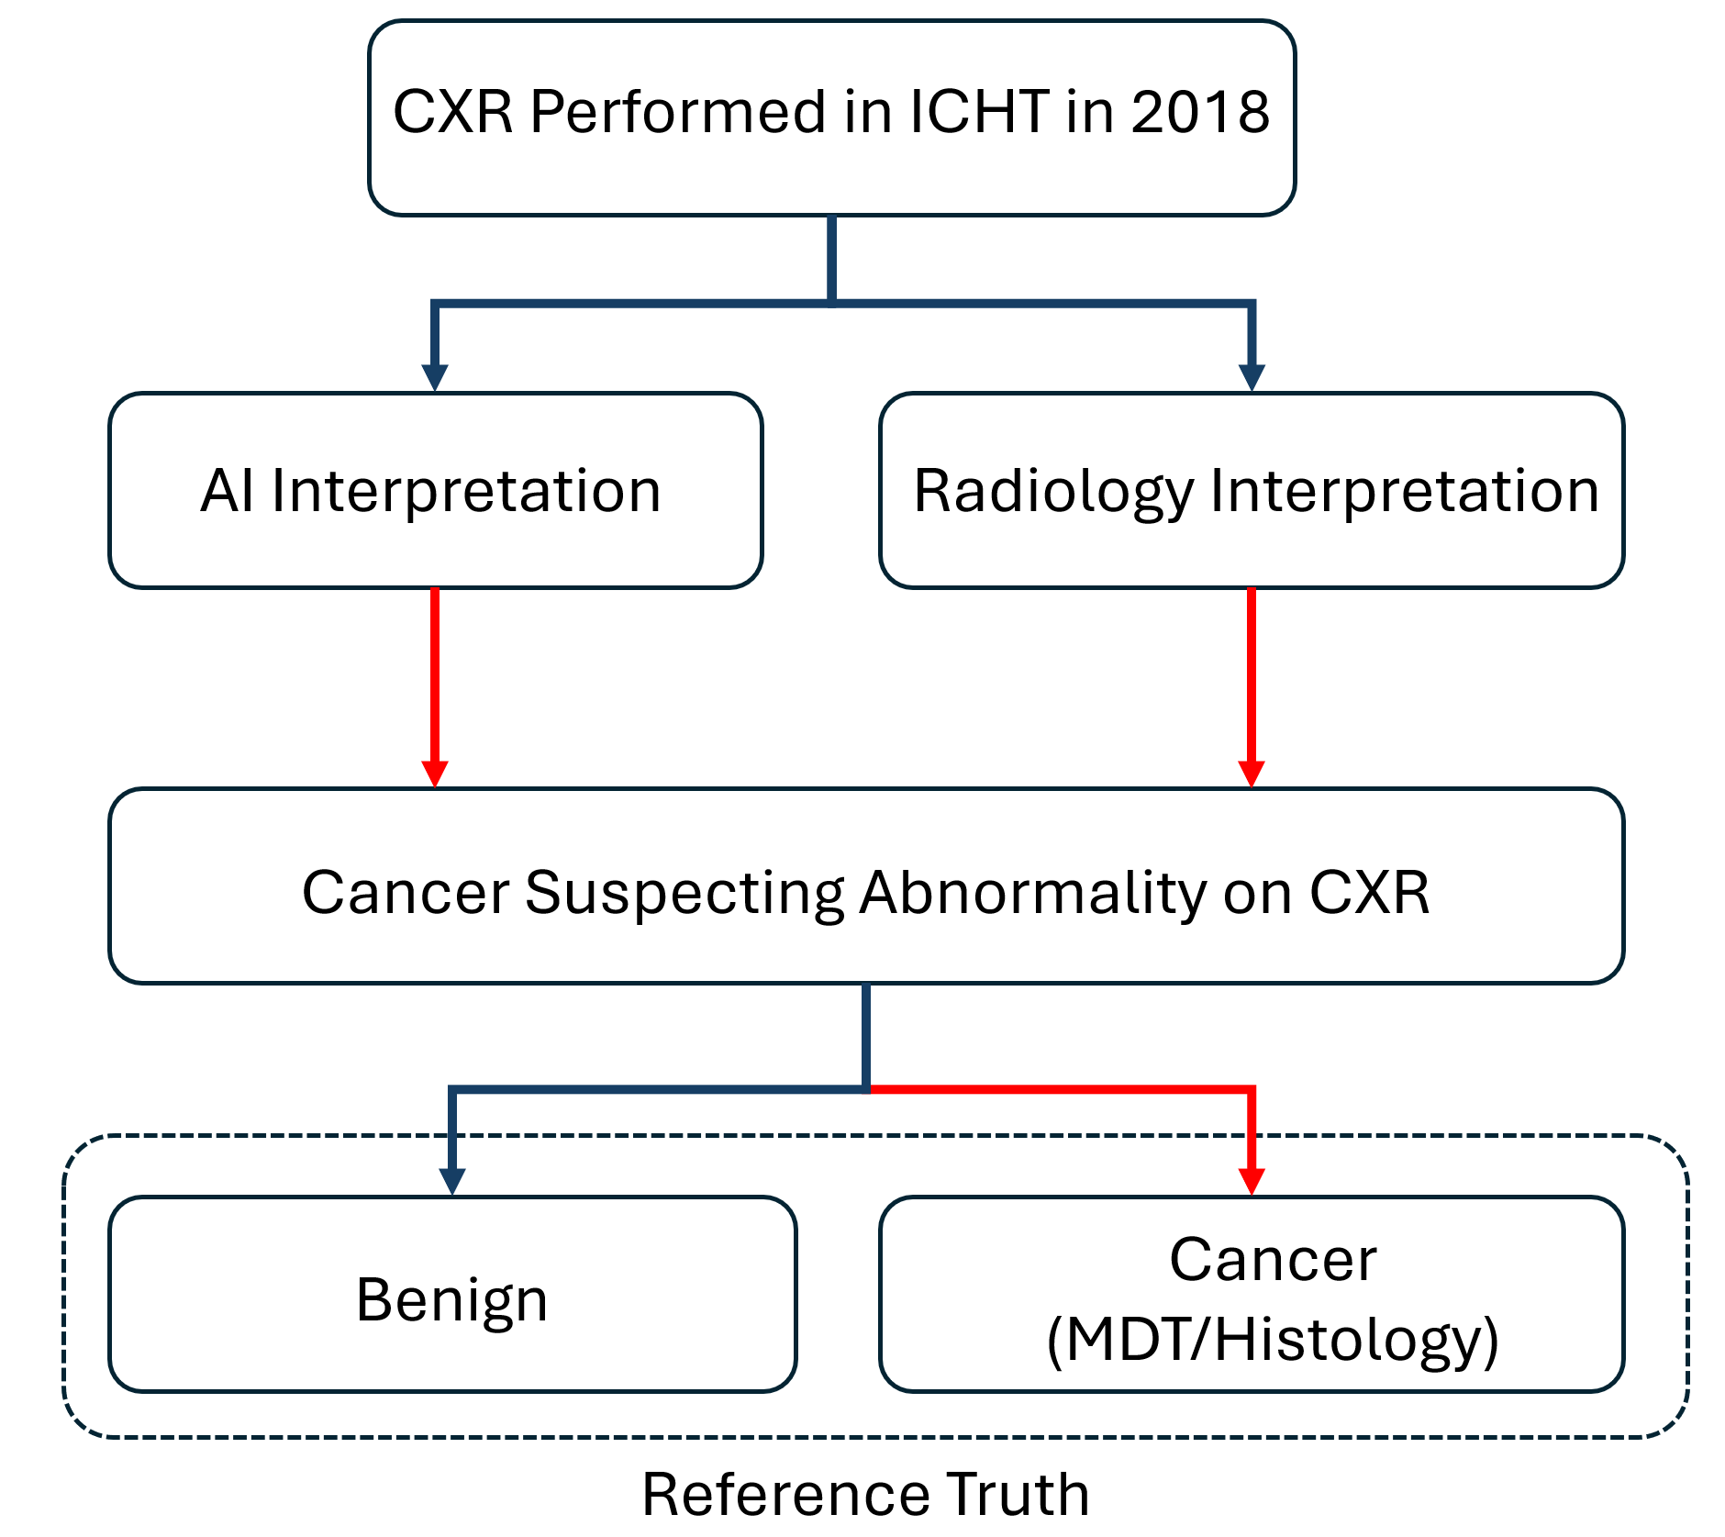
Figure 2: Study design with the reference truth obtained on retrospective follow-up of any cases with cancer suspecting abnormality detected on AI and/or radiology report.
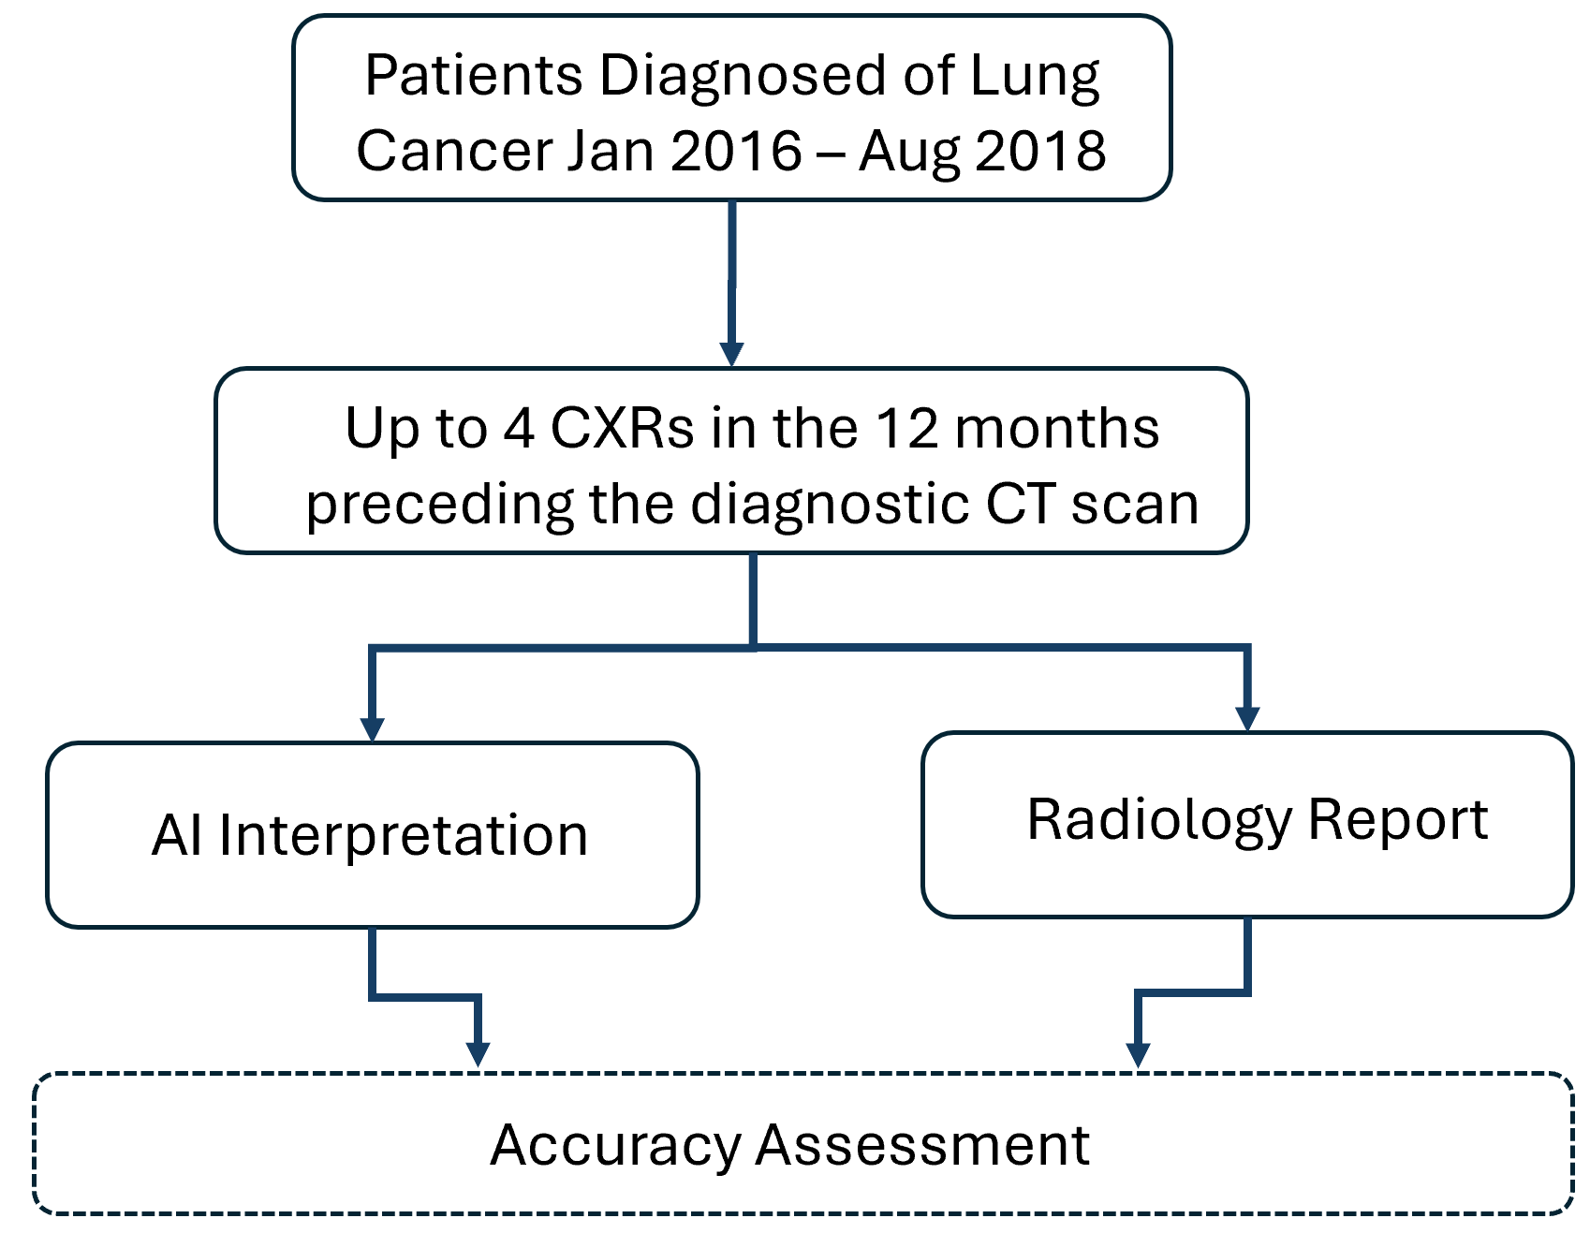
Figure 3: Design of a sub-study looking at patients with confirmed lung cancer

Secondary outcomes include other diagnostic performance measures including specificity, positive and negative predictive values, and area under the ROC curve.

The radiological interpretation of the CXR will be additionally compared to the AI output, with any cancer suspecting findings benchmarked as a secondary study objective. The radiological report stating either follow up imaging or referral to lung cancer MDT will be included as ‘suspected lung cancer’.
Cases where the diagnosis was made on CT will included if they have a CXR within 6 weeks prior to the CT.

For suspected cancer abnormalities detected by AI, the case will be followed up on subsequent imaging and MDT outcomes to establish whether it was a true positive case of suspected cancer.
In the case where the AI CXR did not show cancer, but it was subsequently detected on CT within 3 months, the case would be highlighted and pooled into a separate group for further evaluation to assess whether it constitutes a false negative case.

The actual chest CT referral numbers during the study period will be compared with referral numbers if the AI software was used, with additional flagged CXRs (not all of which would have led to a cancer diagnosis).

We will be evaluating AI failure rate and identifying potential patient and technical factors which contribute to this, such as specific disease or clinical states (pleural effusion, emphysema, cardiac failure, presence of iatrogenic devices etc.), and technical limitations (such as portable CXRs, poor inspiratory effort, patient rotation etc.).We will also assess the technical failure and rejection rates of the AI software.

Failed cases are defined as those failing AI software analysis/processing. Two experienced readers (thoracic radiologists) will evaluate the cases not analysed by AI, to identify causative factors for failure.

PARTICIPANT ENTRY

  - INCLUSION CRITERIA

- Patients aged 18 and over.

- Patients who had an Outpatient, Emergency Department or a General Practitioner referral for a chest X-ray.

- Patients with a CXR available on ICHT PACS who have undergone CXR examination between January 2018 and December 2018.

- Patient diagnosed with lung cancer at ICHT between January 2016 and August 2018 who have had CXR in the 12 months preceding their diagnostic CT scan.

  - EXCLUSION CRITERIA

- Corrupted DICOM files.
- No known outcome to the cancer question
- CXR not suitable for AI software analysis (Appendix 1)
- CXR not available on ICHT PACS

ADVERSE EVENTS

This is a retrospective observational study using data acquired as part of routine clinical care; no adverse events will be recorded or reported.

ASSESSMENT AND FOLLOW-UP

There will be no prospective follow-up for patients as part of the study as the study involves retrospective data collection.

Since this is a retrospective data collection, the end of the study is marked as the end of data collection.

STATISTICS AND DATA ANALYSIS

The sample size will be 53,000 CXRs obtained between January 2018 and December 2018 (inclusive) at ICHT and a subset of approximately 1,000 CXRs taken from patients diagnosed of lung cancer at ICHT between January 2016 and August 2018. Diagnostic performance measurements (sensitivity, specificity, positive and negative predictive values, area under the ROC curve) will be calculated based on the observed true positives, true negatives, false positives and false negatives.

The failure rates will be computed as a percentage of the total number of CXRs included, and the ones associated with each AI-limiting patient and technical factor will be compared to the overall rate.

A stratified analysis of the AI software performance by disease stage (as per IASLC 7th edition, that was used at the time of diagnosis), source of referral (GP/OP/ED) and reason of referral (suspected cancer/incidental cancer finding) will be performed.

Ordinal demographic factors such as patient age and cancer stage will be compared between failed and successful cases using Student t-test with a statistical significance threshold of 5% used.

Using a method described for diagnostic accuracy studies, [8] assuming a Type 1 error of 5% and margin of error of 10%, and based on findings from a qXR pilot study:[9] sensitivity of 71.4% and specificity of 97.7% and a suspected malignant nodule prevalence of 7% observed (35 out of 500 CXRs in the test cohort), the number required is calculated to be 1116 for the primary outcome measure of test sensitivity; which are satisfied by the proposed sample size.

Data and all appropriate documentation will be stored for a minimum of 5 years after the completion of the study, including the follow-up period.

REGULATORY ISSUES

  - ETHICS APPROVAL

The Study Coordination Centre has obtained approval from the Health Research Authority (HRA). The study must also receive confirmation of capacity and capability from each participating NHS Trust before accepting participants into the study or any research activity is carried out. The study will be conducted in accordance with the recommendations for physicians involved in research on human subjects adopted by the 18th World Medical Assembly, Helsinki 1964 and later revisions.

  - CONSENT

As the study involves a pseudonymised dataset which is collected by the direct care team then consent is not required in line with NIHR/HRA guidelines and GDPR compliance.

  - CONFIDENTIALITY

The Chief Investigator will preserve the confidentiality of participants taking part in the study and is registered under the Data Protection Act.

Data will be pseudonymised.

  - INDEMNITY

Imperial College Healthcare NHS Trust holds standard NHS Hospital Indemnity and insurance cover with NHS Resolution for NHS Trusts in England, which apply to this study.

  - SPONSOR

Imperial College Healthcare NHS Trust will act as the main Sponsor for this study. Delegated responsibilities will be assigned to the NHS trusts taking part in this study.

  - FUNDING
This study is funded by the AI Diagnostic Fund.

  - AUDITS

The study may be subject to audit by Imperial College Healthcare NHS Trust under their remit as sponsor and other regulatory bodies to ensure adherence to GCP and the UK Policy Frame Work for Health and Social Care Research.

STUDY MANAGEMENT

The day-to-day management of the study will be co-ordinated through Tina Stoycheva.

PUBLICATION POLICY

The results of the study will be written and will be submitted for publication with suitable journals, and presentation at conferences. All contributing study team members and/or external collaborators will be included as co-authors, the latter at the discretion of the Chief Investigator.

REFERENCES

- Cancer Research UK, https://www.cancerresearchuk.org/health-professional/cancer-statistics/statistics-by-cancer-type/lung-cancer/incidence, Accessed August, 2023.
- Ferlay, J. , Soerjomataram, I. , Dikshit, R. , Eser, S. , Mathers, C. , Rebelo, M. , Parkin, D. M., Forman, D. and Bray, F. (2015), Cancer incidence and mortality worldwide: Sources, methods and major patterns in GLOBOCAN 2012. Int. J. Cancer, 136: E359-E386.
- Association between time-to-treatment and outcomes in non-small cell lung cancer: a systematic review - PubMed (nih.gov)
- Tam MDBS et al., Augmenting lung cancer diagnosis on chest radiographs: positioning artificial intelligence to improve radiologist performance, Clinical Radiology, https://doi.org/10.1016/j.crad.2021.03.021
- NICE Artificial intelligence for analysing chest X-ray images Medtech innovation briefing Published: 29 March 2022 (www.nice.org.uk/guidance/mib292)
- https://www.behold.ai/case-studies/somerset-nhs-foundation-trust-case-study/
- https://www.nice.org.uk/guidance/hte12/resources/evidence-generation-plan-for-artificial-intelligencederived-software-to-analyse-chest-xrays-for-suspected-lung-cancer-in-primary-care-referrals-13186853101/chapter/1-Purpose-of-this-document
- Akoglu H. User’s guide to sample size estimation in diagnostic accuracy studies. Turk J Emerg Med [Internet]. 2022 Oct 1 [cited 2024 Sep 19];22(4):177. Available from: /pmc/articles/PMC9639742/
- Tadepalli M, Chhaparwal A, Chawla S, Srivastava S, Dao T, Codlin A, Naren S, Sathyamurthy S, Mukkavilli SV, Putha P, Reddy B, Vo L, Warrier P. PP01.59 Performance of a Deep Learning Algorithm for the Early Detection of Malignant Lung Nodules. Journal of Thoracic Oncology [Internet]. 2023 Mar 1 [cited 2024 Sep 19];18(3):e35. Available from: http://www.jto.org/article/S1556086422016719/fulltext

Appendix 1: Suitability for qXR analysis

Inclusion Criteria:

Modality: Computed radiography (CR)/Digital radiography (DR)
Patient’s Age > 18 years
Body part Examined: Chest
Patient Position: Erect/Supine
View: Posteroanterior (PA) or anteroposterior (AP)
Format: DICOM (.dcm)
Image Resolution: Minimum of 1440 x 1440

Exclusion Criteria:

Lateral views
Non-Chest X rays
Other modalities
Patient age is less than 18 years

